**DOT-13741: CashNCarry Order Creation Test Results**

Step1:- Pre-setup and Login into Xstore  
Test Step: Passed  
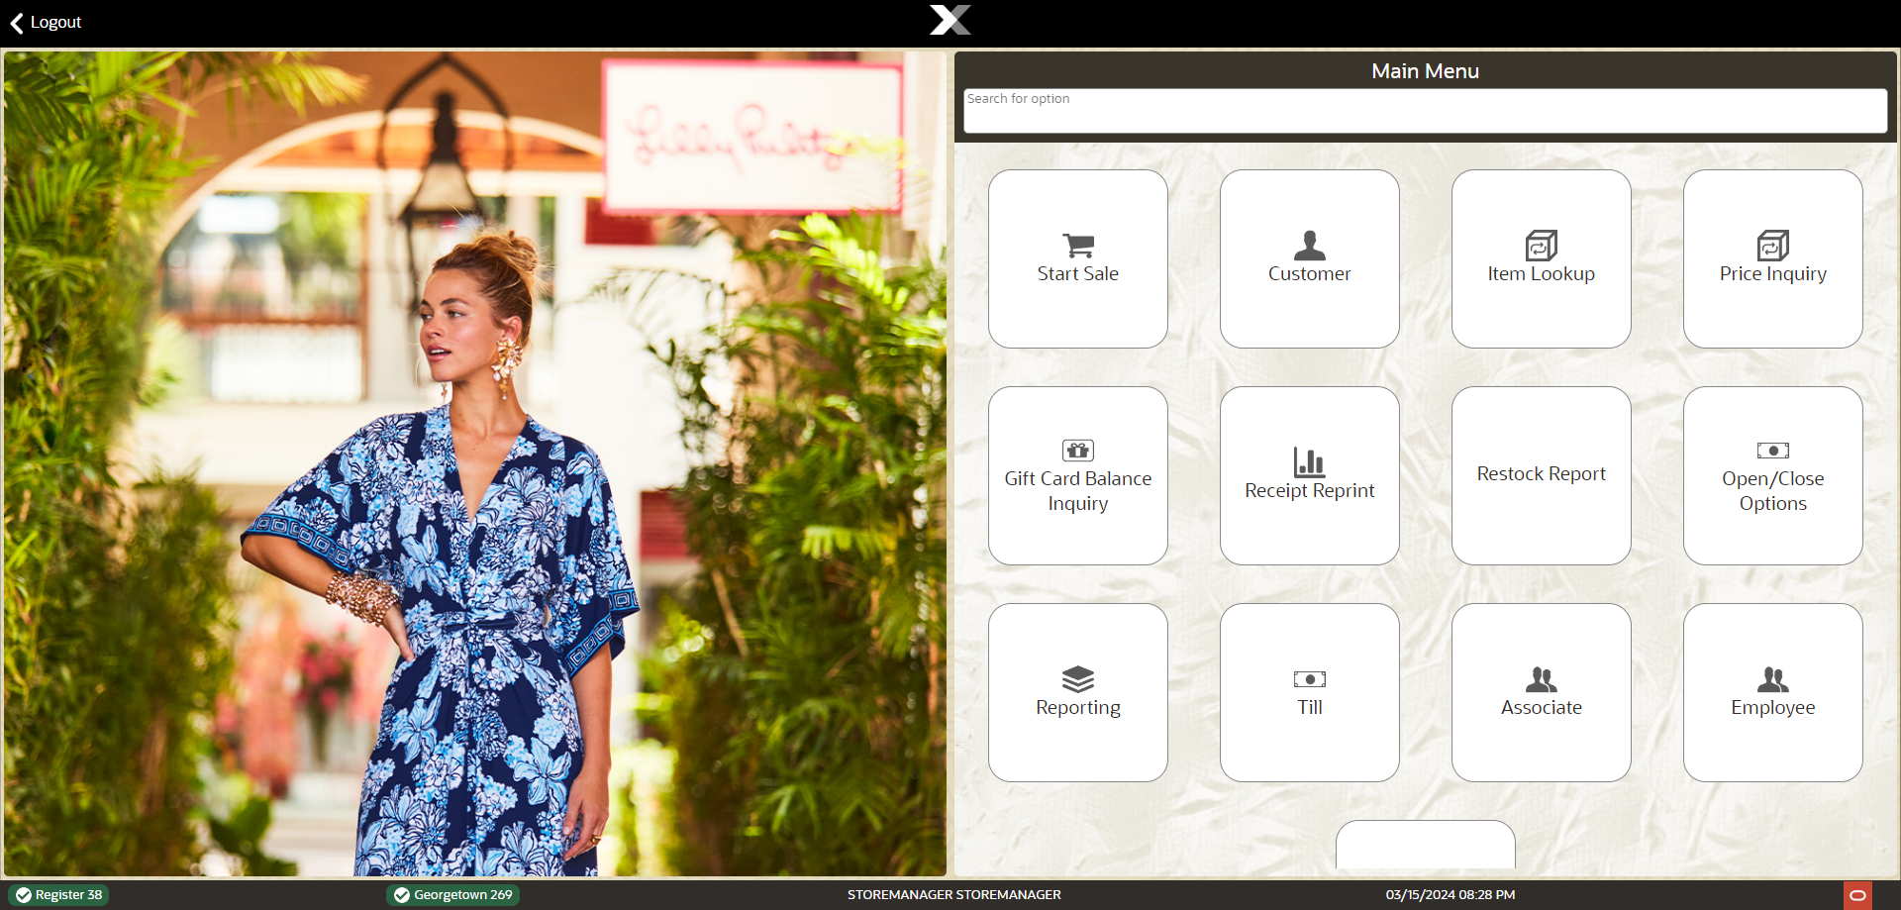

Step2:- Start Sales  
Test Step: Passed  
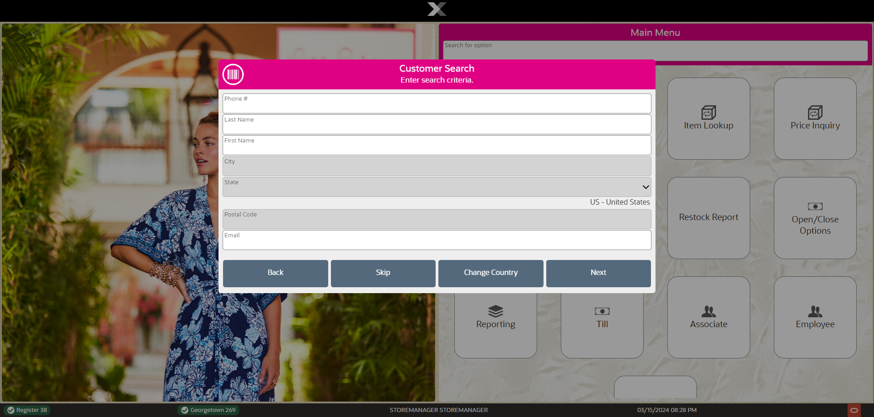

Step3:- Search and Select Customer  
Test Step: Passed  
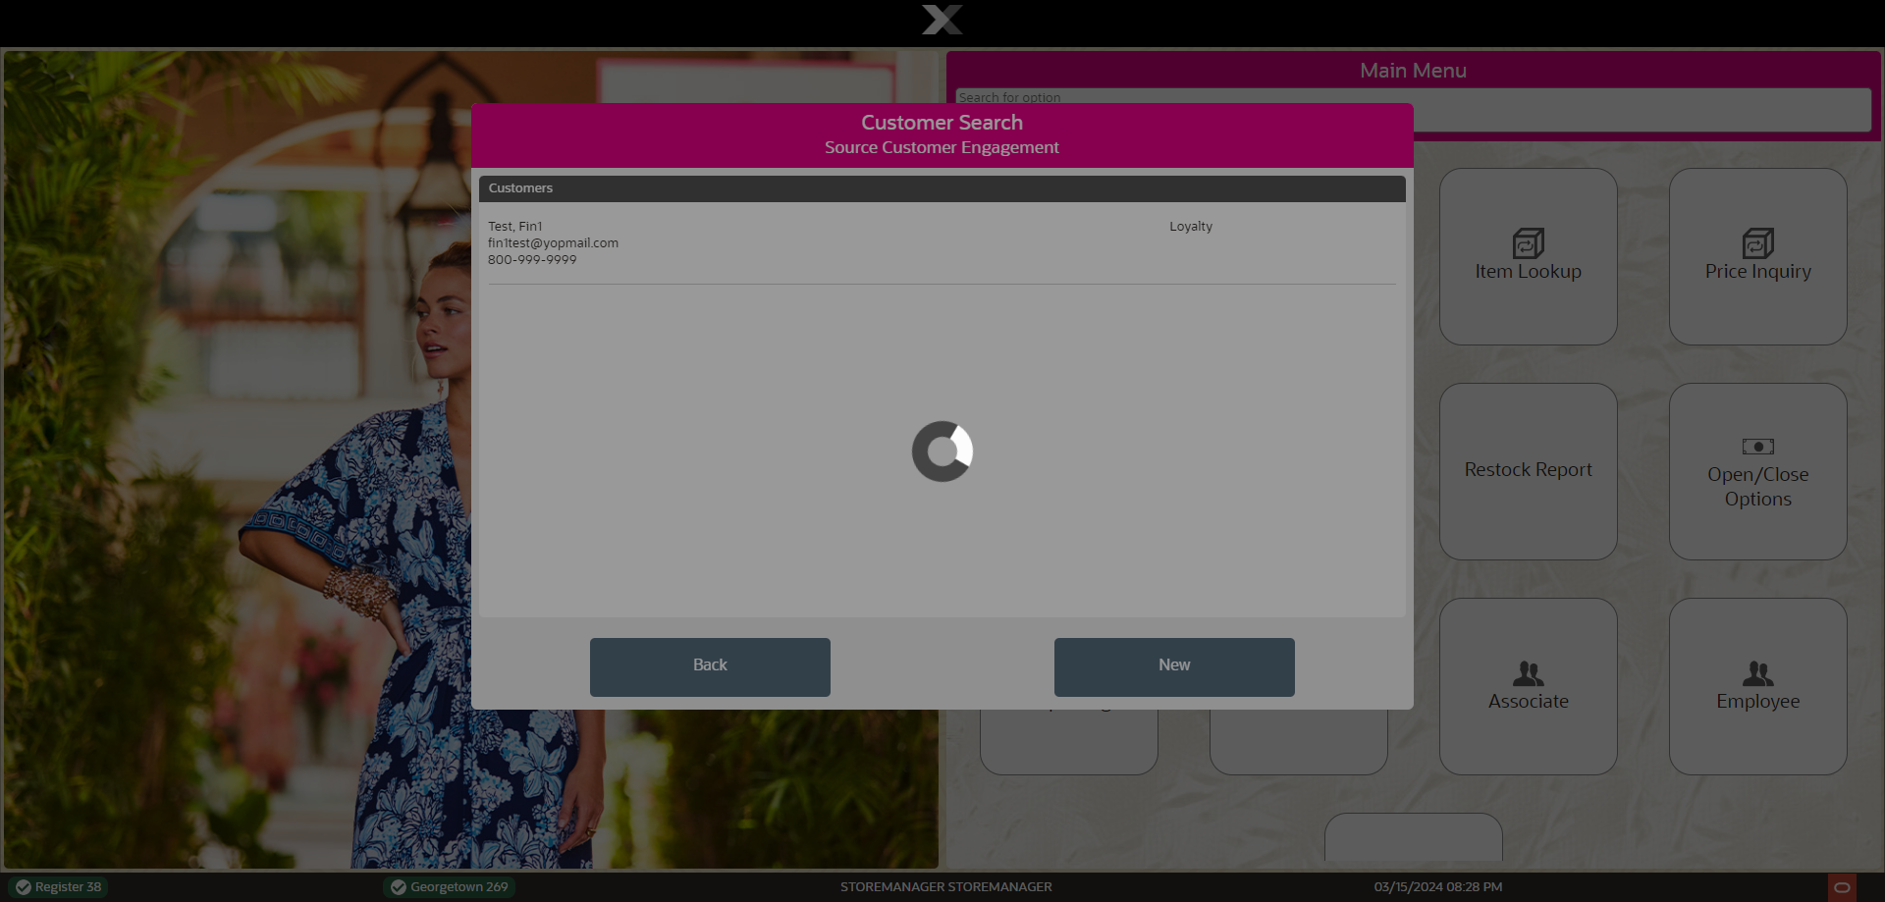

Step Error:- Delayed response or Error Occured  
Test Step: Failed  
